Exhibitions of young Polish artists within the framework of the {Project Room} programme at the Ujazdowski Castle Centre for Contemporary Art in 2018

As part of this year's {Project Room} programme at the Ujazdowski Castle Centre for Contemporary Art, we will see the latest works by six young artists, selected on the basis of portfolios of two hundred candidates.
All invited artists receive the same budget and full production assistance from the Ujazdowski Castle Centre for Contemporary Art. Young curators who will work with the artists have also been invited to the project. From among the solo projects presented this year, the international jury will select two exhibitions and reward them with the 1st Prize – in the amount of PLN 20,000 and the 2nd Prize – PLN 10,000. We will get to know the winners in January 2019.
26 April – 27 May 2018  Grzegorz Stefański  Born in 1983, Grzegorz Stefański lives and works in London and Warsaw. He mainly works with time-based media and is primarily concerned with identity and embodiment.  Graduated from the faculty of Philosophy at the Jagiellonian University in Cracow, Poland and Photography at Art University in Poznan, Poland. In 2016 he graduated from Miroslaw Balka’s Studio of Spatial Activities at the Fine Arts Academy in Warsaw before he received the Felix Slade award to come and  do a Fine Art postgraduate degree at the Slade School of Fine Art in London. In 2017 he was awarded Ivan Juritz Prize in London and Grand Prix at Young Art Biennale in Poland.  He made his debut in 2010 with solo exhibition emptybottles in Goldex-Poldex Gallery in Cracow, Poland. Since then his works were presented e.g. in Whitechapel Gallery in London (2018), in Bloomsbury Theatre, London (2017), during Manifesta 11  in Zurich (2016), in Pastificio Cerere Foundation in Rome (2014) and during NY Art Book Fair in MoMa PS1 in New York (2010). He cooperated with The New Theatre in Warsaw, Królikarnia/  The National Museum in Warsaw and Bunkier Sztuki Gallery  in Cracow among the others. grzegorzstefanski.com | 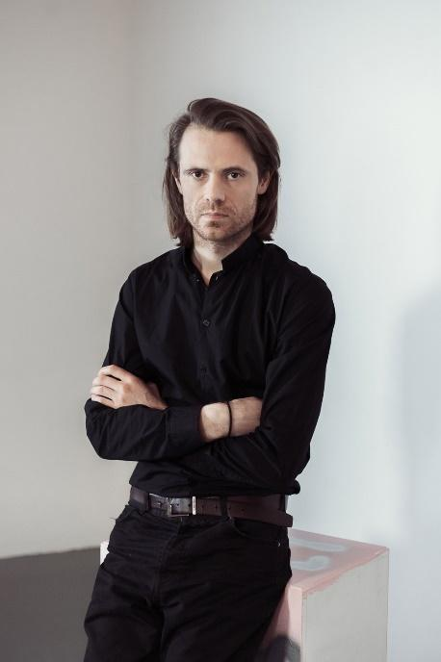  Photo by Karolina Zajączkowska / Ujazdowski Castle Centre for Contemporary Art
07/06–15/07/2018  Maria Toboła  Born in 1987 in Leszno. A graduate of the University of Arts in Poznań. She completed her diploma at the studio of Audio-sphere run by Professor Leszek Knaflewski in the Inter-media Department.  She works with video, performance, installation, sculpture and poetry. In her works, she often uses word-play and quibbles, irony, absurd, joke. Her realizations can be described as silly and unpalatable examples of conceptual art. She lives and works in Warsaw. | 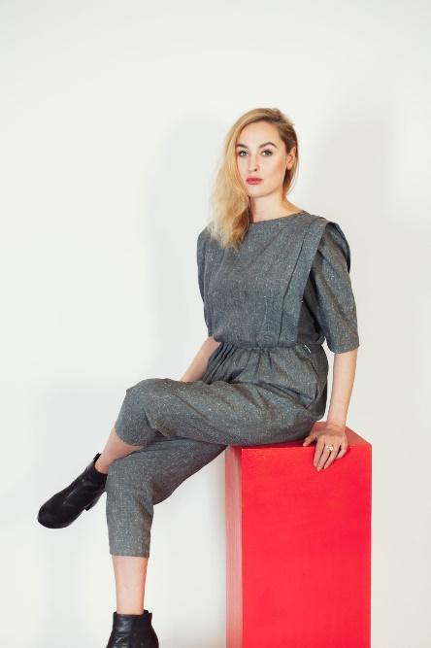  Photo by Karolina Zajączkowska / Ujazdowski Castle Centre for Contemporary Art
19/07–26/08/2018  Weronika Gęsicka  Born in 1984 in Włocławek. A graduate of the Academy of Fine Arts and the Academy of Photography in Warsaw.  She is a recipient of a scholarship from the Minister of Culture and National Heritage. Laureate, among other awards, of Foam Talent (2017), LensCulture Emerging Talent Awards (2016) and ShowOFF section at the Kraków Photomonth Festival (2016). Finalist of the Prix HSBC la Photographie (2017) and Prix Levallois (2016).  In her projects, she takes up topics related to memory and mechanisms of its functioning. She is interested in related scientific and pseudoscientific theories, mnemonics and various kinds of disorders. The area of her activities covers primarily photography, but she also creates objects and various types of artefacts. An important part of her work is working on archival materials. She lives and works in Warsaw. | 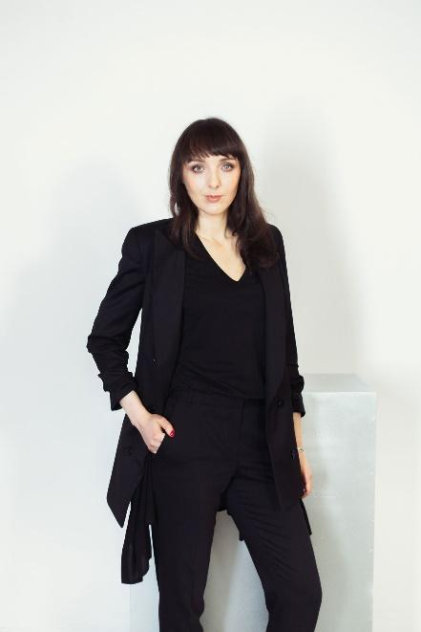  Photo by Karolina Zajączkowska / Ujazdowski Castle Centre for Contemporary Art
30/08–07/10/2018  Ania Nowak  She graduated in choreography at HZT Berlin. He lives and works in Berlin.  Ania Nowak works in the field of widely understood choreography. She creates solo and collective works exploring the tension in language as well as understatement and transformation of the body. Nowak conducts research on love as a knowledge generating strategy (http://technologiesoflove.tumblr.com), where she explores affective economics, unstable structures of concern and attempts to redefine sensuality.  Her works were presented, among other places, in Sophiensaele and Akademie der Künste in Berlin, Nowy Teatr, Ujazdowski Castle Centre for Contemporary Art, Museum of Modern Art in Warsaw, Art Stations Foundation in Poznań, National Centre of Dance in Bucharest and Arts Santa Mònica in Barcelona. | 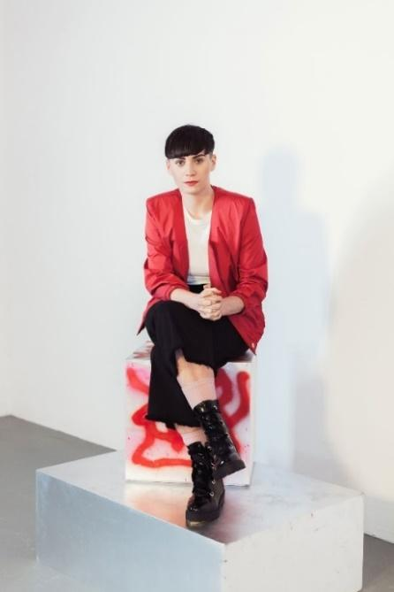  Photo by Karolina Zajączkowska / Ujazdowski Castle Centre for Contemporary Art
11/10–18/11/2018  Karolina Mełnicka  Born in 1988 in Toruń. She graduated in Cultural Studies at the Faculty of Social Sciences of the Adam Mickiewicz University in Poznań (2010) and in multimedia at the Szczecin Art Academy, Faculty of Painting and New Media (2016).  Her artistic quest can be described as a conceptual critical art exploring influences on the mechanisms of a top-down reality. She is particularly interested in observing the methods of designing space or ideas for a mass audience. She deals with 3d animation, video art, photography, object presentation, performance; text plays a particularly important role in her works where she often uses the author's poetic narrative. She is a co-founder of the Nomadic State, which she co-runs with Stach Szumski. She participated in many group and individual exhibitions in Poland and in the world. She lives and works in Warsaw. | 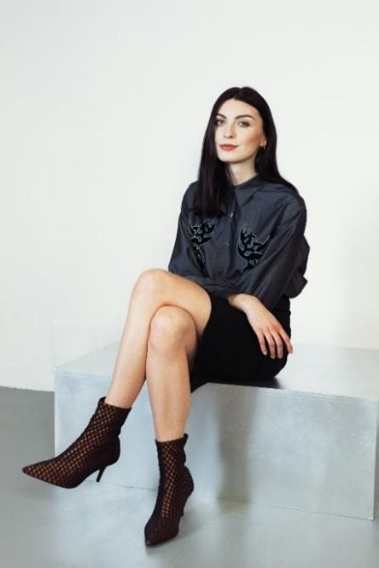  Photo by Karolina Zajączkowska / Ujazdowski Castle Centre for Contemporary Art
22/11–30/12/2018  Karolina Babińska  Karolina Babińska after several years of studies at the faculties of law, cultural studies and graphic art, graduated from the Faculty of Painting and New Media at the Art Academy of Szczecin.  She creates objects and installations, examining the relationship between art objects and the market. She is involved in theatre, conducts educational workshops. Ardent supporter of physical work. She lives and works in Szczecin. | 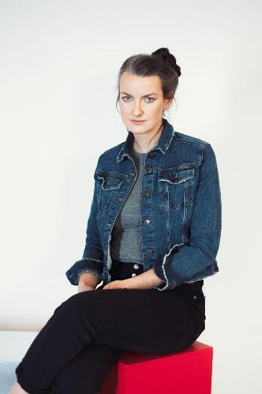  Photo by Karolina Zajączkowska / Ujazdowski Castle Centre for Contemporary Art

Organizer
Ujazdowski Castle Centre for Contemporary Art
Institution financed by
The Ministry of Culture and National Heritage of the Republic of Poland
Media partners
TOK FM, Gazeta Wyborcza, Wyborcza.pl Warszawa, Co Jest Grane 24, AMS, KMAG, Aktivist, Notes Na 6 Tygodni

Press materials
http://u-jazdowski.pl/en/press-room/komunikaty-prasowe/wystawy-w-project-room-2018/project-room-2018

Contact for the media
Magdalena Gorlas
+ 48 500 198 274
+48 22 628 12 71 ext. 124
m.gorlas@u-jazdowski.pl

